Essex Dance Theatre
www.essexdancetheatre.co.uk

Essex Dance Theatre is a self-financing, non- profit making Youth Arts Dance project working under cost neutral auspices of Essex County Council

“Where the art is in the teaching.” Daily Telegraph

Dance Inclusion - A fully inclusive & open group developing a creative language to improve personal development & learning. To entertain, develop & challenge misconceptions of who can perform and who can choreograph. “Dance Inclusion” is for young adult dancers with learning disabilities, an exciting and inspiring approach to integrated dance.
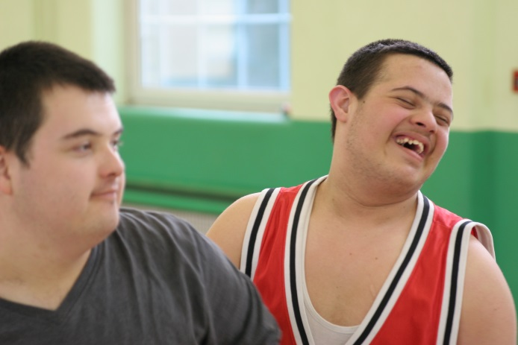

Held at : Essex Dance Theatre, Dorset Avenue, Great Baddow CM2 9UB
On the same site as Larkrise Primary School, parking, foyer for waiting careers. Easy bus route.
On: Friday 5-6pm
Just come along and see if we are what you are looking for ~
01245 476335

Essex Dance Theatre supported by

